Presentation of numerous systems

Author: Blagorodna Lazova
Subject: Programming Languages for III year
Topic: Presentation of data computer. General data types
Level: High school
Language: Macedonian Language
Type of material: Electronic teaching material for the presentation of numerous computer systems
Material Format : Text document

Abstract: Numerous systems in which each digit in the number is specified, positional number systems. Besides positional number systems exist antipozicioni numerous systems, they are a different type of number in which regardless of the position where the meaning of the figures is same. In this material are described a number of these systems and their conversion from one numeral system to another. Through a growing number of adequately solved examples students can easily master the procedure for converting numbers from one numeral system to another.

Content

1. Numerios systems 3
1.1 Decades number system 3
1.2 Commonly used positional number systems 3
1.3 Converting a decimal integers in binary 4
1.4 Converting a decimal decimal numbers into binary 7
2. Octal number system 8
3. Heksadecal number system 8
4. Converting binary in oktalen and heksadekaden number system 8
5. Conversions between decade, binary, octal and heksadekaden number system 9
6. Operations in binary number system 12
6.1 Aditional 12
6.2 Deduction 12
6.3 Multiplication 13
6.4 Dividing 13
7. Representing numbers in a computer 14
7.1 Bit, byte and word 14
7.2 Presentation of the characters in the computer 14
7.3 Representation of numbers in the computer 15

1. Numerous systems

Each digit in the number has its own importance.
For example, the numbers in the decimal number 9275.34 have the following significance: 5 units, 7 tens, 2 hundred, 9 thousand, three-tenths and 4 hundredths. The number can also be written as:
9·10³ + 2·10² + 7·10¹ + 5·10⁰ + 3·10⁻¹ + 4·10⁻².
Degrees base 10 (3,2,1,0, -1 and -2) determine the importance of the figure number, each digit in the number is specified, depending where it is located. Such systems are called numerous positional number systems.
Besides positional number systems exist antipozicioni numerous systems, they are a different type of number systems. Positional differ from that position regardless of the significance of the figure is the same. Example antinepozicionen numeral system is the record of the Roman numbers.

Ex numbers I, IX, XXI. The unit in the first number means 1. The second number means 1 10, and the third number 1 then 20. In all three cases I have important first

Decades number system

Decade number system belongs to the positional number system and uses the numbers 0,1,2,3,4,5,6,7,8 and 9 but apart from all that use decimal numbers. Decade number system belongs to the group positional number systems.

1.2 Commonly used positional number systems
1.Dekaden- base 10 with figures 0,1,2,3,4,5,6,7,8,9.
2.Binaren- base 2 and base 0,1.
3.Oktalen- base 8 and with figures 0,1,2,3,4,5,6,7.
4.Heksadekaden- base 16 numbers and 0.1, 2,3,4,5,6,7,8,9, A, B, C, D, E, F.

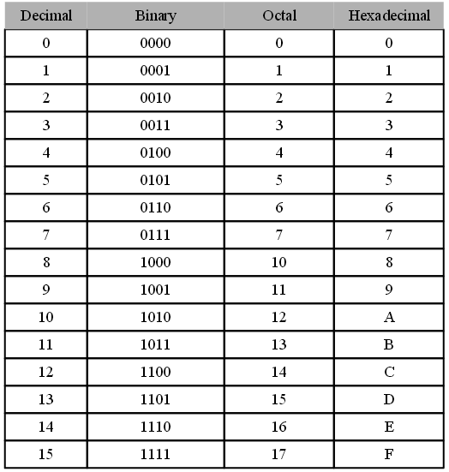
Figure 1. Table of numerous positional системи

1.3 Converting a decimal integers in binary

The data is entered in the decade numerical system understandable to man and computer work with numbers written in binary numeral system because they need to perform binary. Then binary data should be presented in a decade to be understood by man. There is a procedure of three steps for converting a number from a decade in the binary number system.

- Step1
Given number in decade number system is divided by 2 and Remains (which can be 0 and 1) is recorded;
• Step 2
again resulting quotient is divided by 2, and the remainder (0 or 1) is recorded; Dividing ratio until does not receive residual value 0 and 1.
• Step 3
residues obtained are recorded in descending order of the sequence of dobivanjeto- it is an entry number in binary numeral system.

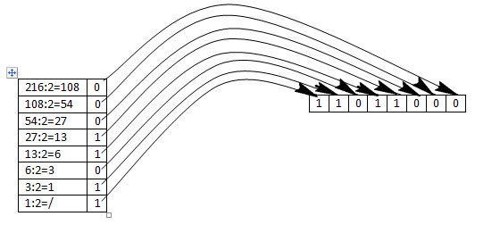
Figure 2. View of turning from decade to binary recording

Ex 1. Decade number 671890 turn the binary number system.

671890:2=335945 residual 0
335945:2=167972 residual 1
167972:2=83986 residual 0
83986:2=41993 residual 0
41993:2=20996 residual 1
20996:2=10498 residual 0
10498:2=5249 residual 0
5249:2=2624 residual 1
2624:2=1312 residual 0
1312:2=656 residual 0
656:2=328 residual 0
328:2=164 residual 0
164:2=82 residual 0
82:2=41 residual 0
41:2=20 residual 1
20:2=10 residual 0
10:2=5 residual 0
5:2=2 residual 1
2:2=1 residual 0
1:2=0 residual 1

671890₁₀=10100100000010010010₂

Ex. 2. The number 125 of the decade to turn into a binary number system.

125:2=64 residual 1
64:2=31 residual 0
32:2=16 residual 0
16:2=8 residual 0
8:2=4 residual 0
4:2=2 residual 0
2:2=1 residual 0
1:2=о residual 1

125₁₀= 10000001₂

Decade integers in converting into binary always shared with the 2
• Apart from the conversion of the decade in binary, it can perform a reverse process (the binary in the decade).

Ex. 3 11100101 The number of binary turn in the decade numerical system.

11100101₂= 1·2⁷ + 1·2⁶ + 1·2⁵ + 0·2⁴ + 0·2³ + 1·2² + 0·2¹ + 1·2⁰ =
1·128 + 1·64 + 1·32 + 0·16 + 0·8 + 1·4 + 0·2 + 1·1=
128 + 64 + 32 + 4 + 1= 229₁₀

1.4 Converting a decimal decimal numbers into binary

To turn Decade decimal number binary needs to be turned purposes, especially decimalinot part. Decimaliniot part turns the following procedure

- Step 1
The number is multiplied decimal part 2 and remember all of the product.
• Step 2
then again multiplied by 2 only the decimal part of the previously obtained product and remember all of the newly product etc.
• Step 3
procedure lasts until decimal part of the product is not 0 (but since the latter proceedings is not always final because broken when receiving a number bits).

Ex 1. Decade Decimal 378.6 introduced the binary.

378₁₀=101111010₂

0.6·2
0.2·2 1
0.4·2 0
0.8·2 0
0.6·2 1
0.2 1

378.610=101111010.10011₂

Ex 2. Decade Decimal 0.63092 introduced the binary
.

0.63092·2
0.26184·2 1
0.52368·2 0
0.04736·2 1
0.09472·2 0
0.18944 0

0.63092₁₀=0.10100₂

Decade decimal numbers in the binary conversion multiplied by 2

2. Octal number system

The basis for Octal number system is 8. For the calculation of the numbers used numbers 0,1,2,3,4,5,6 and 7.

Ex: 231,57₈= 2·8² + 3·8¹ + 1·8⁰ + 5·8⁻¹ + 7·8⁻²= 153,8187₁₀

3. Heksadecal number system

Basically the system is heksadekadniot numeral 16. For the calculation known except to 9 digits for representing the numbers of useful symbols A, B, C, D, E, F which are suitable for 10,11,12,13,14 and 15 respectively.

4. Converting binary in oktalen and heksadekaden number system

There is an easier way of converting binary in okralen and heksadekaden number system. This is done by grouping the bits in groups of 3 for Octal and 4 for heksadekaden starting from the decimal point, left and right.

Ex 1. From the binary in octal in groups of 3 digits
110001110001.101100000010₂ binary number
110 001 110 001.101 100 000 010₂= 3- bit groups
6 1 6 1 . 5 4 0 2₈ Octal equivalent for each group

Ex 2. Binary in heksadekaden in groups of 4 digits
1100 0111 0001.1011 0000₂ binary number
1100 0111 0001.1011 0000₂= 4- bit groups
0010 ₂= C 7 1 . B 0 2₁₆ heksadekaden equivalent for each group

5. Conversions between decade, binary, octal and heksadekaden number system

Ex 1. Decade number 671890 turn to octal number system.

671890:8=83986 residual 2
83986:8=10498 residual 2
10498:8=1312 residual 2
1312:8=164 residual 0
164:8=20 residual 4
20:8=2 residual 4
2:8=0 residual 2

671890₁₀=2440222₈

Ex 2. Decade number 0.9140625 turn to octal number system.

0.9140625·8= 7.3125 be remembered 7
0.3125000·8= 2.5000 be remembered 2
0.5000000·8= 4.0000 be remembered 4

0.9140625₁₀= 0.724₈

Ex 3. Decade number 671890 turn in heksadekaden number system.

671890:16=41993 residual 2
41993:16=2624 residual 9
2624:16=164 residual 0
164:16=10 residual 4
10:16=0 residual А

671890₁₀=А4092₁₆
Ex 4. Decade decimal number 0.9091796875 turn in heksadekaden number system.

0.9091796875·16= 14.546875 be remembered Е
0.5468750000·16= 8.750000 be remembered 8
0.7500000000·16= 12.000000 be remembered С

0.9091796875₁₀= Е8С₁₆

Ex 5. Each of these decimal number turn into binary, and heksadekaden Octal number system.

а) 19
19:2=9 residual 1
9:2=4 residual 1
4:2=2 residual 0
2:2=1 residual 0
1:2=0 residual 1
19₁₀=10011₂

б) 19
19:8=2 residual 3
2:8=0 residual 2
19₁₀=23₈

в) 19
19:16=1 residual 3
1:16=0 residual 1
19₁₀=13₁₆

г) 10
10:2=5 residual 0
5:2=2 residual 1
2:2=1 residual 0
1:2=0 residual 1
10₁₀=1010₂

Ex 6. Convert the following binary numbers, octal, heksadekaden in decade number system.

а) 11011₂=1·2⁴ + 1·2³ + 0·2² + 1·2¹ + 1·2⁰= 16+8+0+2+1= 27₁₀

б) 571₈=5·8² + 7·8¹ + 1·8⁰= 320+56+1= 377₁₀

c) АB1616=10·16³ + 11·16² + 1·16¹ + 6·16⁰= 40960+2816+16+6=43798₁₀

Ex 7. Turn following decade decimal numbers in octal:

a) 0.63092

0.63092*8
0.04736*8 5
0,37888*8 0
0,03104*8 3
0,24832*8 0
0,98656 1

0.63092₁₀=0.50301₈

б) 378.6

378₁₀=572₈

0.6*8
0.8*8 4
0.4*8 6
0.2*8 3
0.6*8 1
0.8 4

378.6₁₀=572.46314₈

6. Operations in binary number system

6.1 Aditional

The collection in the binary number system and the Decade is the same. The sum of the numbers in the binary numeral system are:

0+0=0; 1+0=1; 0+1=1; 1+1=0
Пр:
a) 110111
+100001
1011000

б) 1111000
+1000111
10111111

6.2 Deduction

In the binary number system, to display negative numbers is using twos complement. Double complement the number 010110110110 number 101001001010. Double complement is obtained in two steps
- Step 1
First making replacement of the bit (1 is replaced with 0, 0 and 1) If the number 010110110110 complement his single is 101001001001.
• Step 2
Double complement obtained from the unit so that the unit is added first
Пр 1:
101001001001 the single number complement
+ 1 add 1
101001001010 twos complement number

Пр 2: 1100-101= ? It requires a double complement of 0101

0101 number reducer

1010 the single number complement
+ 1
1011 twos complement number

1100
+1011
10111

6.3 Multiplication

Multiplies the numbers in the binary numeral system

0·0= 0; 1·0= 0; 0·1= 0 и 1·1= 1.

Пр 1: 101· 11
101
101
1111

Пр 2: 110001·111
110001
110001
110001
101010111

6.4 Dividing

Rules binary multiplication can execute binary division.
Пр 1: a) 10111110001:1101=1110101
- 1101
10101
- 1101
10001
- 1101
010000
-1101
001101

-1101
0000

7. Representing numbers in a computer

7.1 Bit, byte and word

The computer can process text, images, sounds and numbers. We call data. The presentation of the data in the computer is done with bits (bit is an abbreviation of the English word binary digit- bit, which means binary digit, it is the basic unit for measuring the amount of information). One bit is the iznachuva 1b, which contain 0 or 1. A group of eight bits is called a byte and a basic unit for expressing the memory capacity. At one byte (which is a combination of 8 bits) can be written one letter, number or special character. Polubajt is a group of four bits and is called nibbles. As a result of today's computers that have a large memory capacity, it developed a hierarchy of measures based on byte.

1КВ (Kilo Byte)= 2¹⁰ В= 1024 В
1МВ (Mega Byte)= 2¹⁰ КВ= 1024 КВ
1GB (Giga Byte )= 2¹⁰ МВ= 1024 МВ

A group of several bytes form a word (word). Depending on the computer's CPU word may be composed of a varying number bits.

1 word= 2 В= 16 b (in the case of 16 bit CPU)
1 word= 4 В= 32 b (in the case of 32 bit CPU)
1 word= 8 В= 64 b (in the case of 64 bit CPU))

7.2 Presentation of the characters in the computer

The texts in the computer are expressed by signs and alphabetical (ABC), numeric (numbers 0,1,2,3,4,5,6,7,8 and 9) and special characters (@, #, ^, $, &,* ect). Each character is represented by one byte, which is the only flu of 8 bits and is called a code. This code is unique and is known as ASCII- code (American Standard Code for Information Interchange).

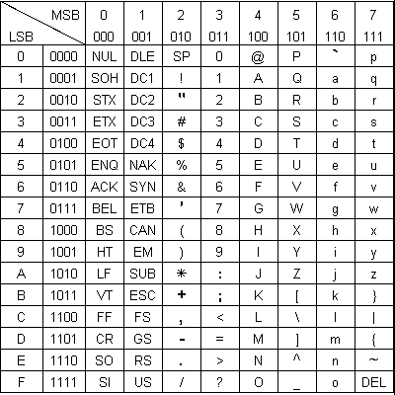
Слика 3. Табела на ASCII- код

For example, the table shows that the code of the letter A is composed of vertical and horizontal group 101 Group 0001 and is the 1,010,001th Code 0110110 sign is so.

7.3 Representation of numbers in the computer

The numbers in the computer are presented in words. How many bits the word depends on the type of CPU of the computer. In 16-bit processor, the entry of integers in 16 bits with the first is marked as a number and 0 a positive and 1 negative number.

1 | 0 | 0 | 0 | 0 | 0 | 0 | 0 | 0 | 0 | 0 | 0 | 0 | 0 | 0 | 0

Sign

0 | 1 | 1 | 1 | 1 | 1 | 1 | 1 | 1 | 1 | 1 | 1 | 1 | 1 | 1 | 1

The largest positive integer in 16 bits.

